Experiment No: 7

Experiment Name: Vulnerabilities Analysis Using CGI Scanning with Nikto

Aim
To analyze web server vulnerabilities by performing CGI directory scanning using Nikto on an authorized test web server.

Procedure
- Open Kali Linux and launch the Terminal.
- Check Nikto options using:
- Perform a basic vulnerability
- Perform CGI directory scanning:
- Observe the vulnerabilities, CGI directories, server information, and other findings displayed by Nikto.
- Record the important findings and save the scan results for analysis.

Output
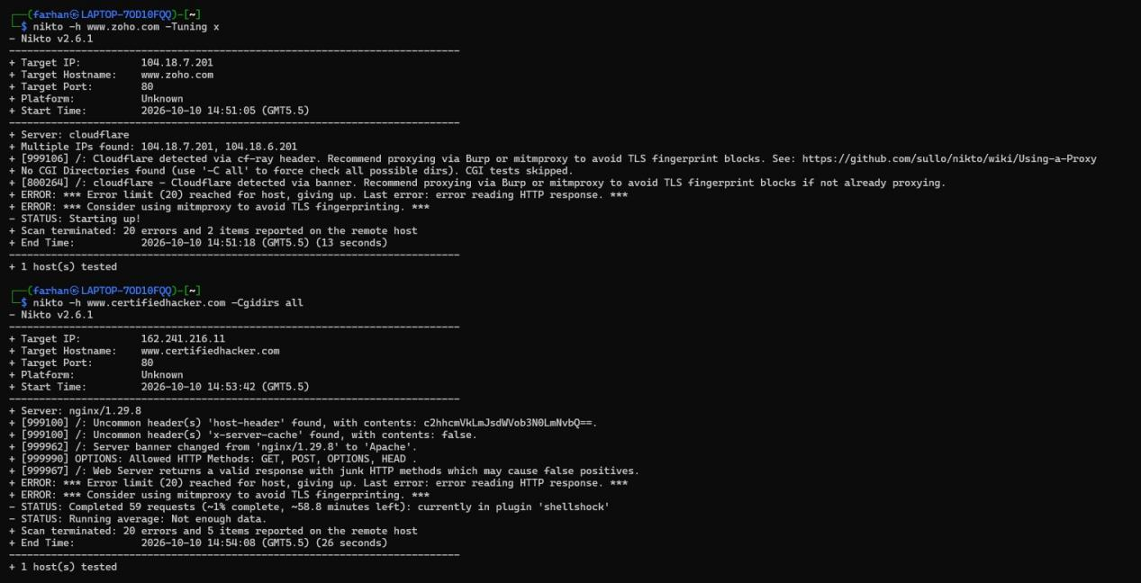

Result
Thus, vulnerability analysis using CGI scanning with Nikto was successfully performed, and the security findings of the authorized web server were identified.

